**NATIONAL UNIVERSITY OF COMPUTER AND**

**EMERGING SCIENCES**

**SL-2002 – Software Design &amp; Architecture Lab**

**Lab Instructor: Zarnain Maryam Awan**

**Lab 05**

**Robustness Diagram:**

A robustness diagram shows the objects that participate in the scenario and how those objects interact with each other. Robustness diagram is of enormous value in helping you refine use case text and discover objects that are needed. You can create a robustness diagram from a scenario or from the use-cases of the scenario.

**Here are the Robustness Diagram symbols:**

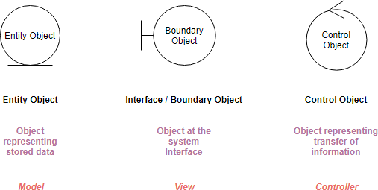

* **Boundary object** (or interface object) is what actors use in communicating with the system.
* **Entity object** is usually an object from the domain model.
* **Control objects** (also known as controllers in MVC), which serve as the “glue” between boundary objects and entity objects.

**Robustness Diagram – 4 Connection Rules:**

Keep in mind that both boundary objects and entity objects are nouns and that controllers are verbs. Nouns can’t talk to other nouns, but verbs can talk to either nouns or verbs.

Here I listed the four basic connection rules which should always be mind:

* Actors can only talk to boundary objects.
* Boundary objects can only talk to controllers and actors.
* Entity objects can only talk to controllers.
* Controllers can talk to boundary objects and entity objects, and to other controllers, but not to actors

Both the boundary objects and entity objects are nouns; the controllers are verbs. Nouns cannot talk to other nouns, but verbs can talk to either nouns or verbs.

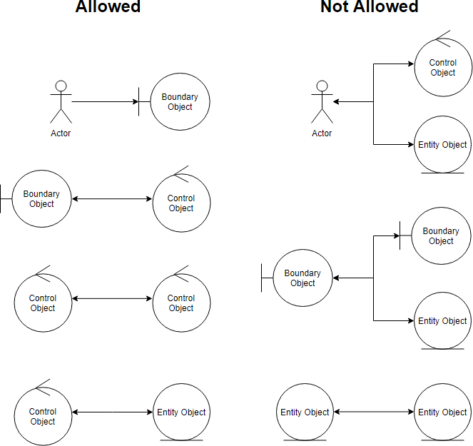

**Five Steps for Creating Robustness Diagram from Use case:**

1. You perform robustness analysis for a use case by walking through the use case text.
2. One sentence at a time, and drawing the actors, the appropriate boundary, entity objects and controllers, and the connections among the various elements of the diagram.
3. You should be able to fit the basic course and all of the alternate courses on one diagram.
4. Anyone who reviews a robustness diagram should be able to read a course of action in the use case text, trace his finger along with the associations on the diagram, and see a clear match between text and picture.

You will probably have to rewrite your use case text as you do this, to remove ambiguity and to explicitly reference boundary objects and entity objects. Most people don’t write perfect use case text in the first draft. So we can use the robustness diagram to bridge the gap between the use case text and the robustness diagram.

**How to Create Robustness or ECB Diagram in Papyrus**

1) Create a papyrus class diagram as discussed in the previous lab. To include the stereotypes of the ECB pattern, click on the right click on the class in the class diagram and go to

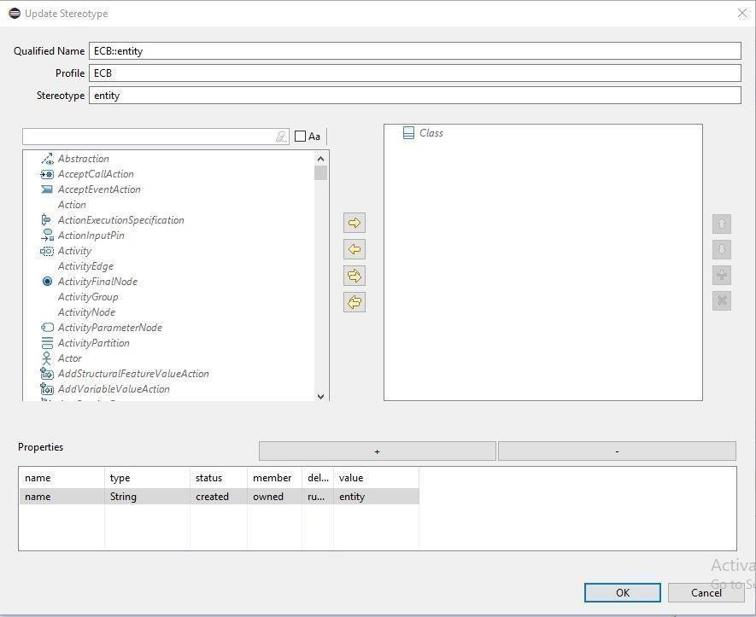

***Profiles Update profile option***

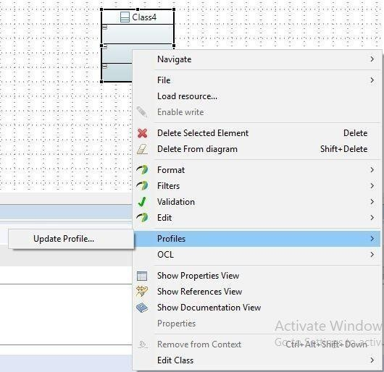

2) Suppose you want to create a class of entity stereotype. Under the update stereotype window, type “entity” in qualified name and enter “ECB” in profile. When you do this, the entity will automatically appear in the stereotype and qualified name will automatically change to "ECB::entity".

Finally, click on + sign beside properties heading and change the name to “name” and value to

“entity” and click on ‘Ok’ as shown in the image below:

**Example 01:Robustness Diagram from the Scenario**

British University Management System is a smart, flexible, and affordable solution that covers all aspects of Universities, Colleges or Schools. It's a complete end-to-end solution that covers every minute aspect of a university workflow which we had used to perform manually.

There are four most important users who behave as Staff, Faculty, Administrator, and Student.

Student will use the system for course registration after proper login with credentials student can also apply for scholarship on the basis on their financial status and merit.

Office Staff are responsible for making class schedule for faculty members, then faculty members run their classes according to defined scheduled.

Faculty are responsible for assigning the grades and maintain the student’s attendance with proper credentials and to achieve these objectives faculty portal offers two sub-portals such as, manage attendance and manage evaluation. They can also provide course feedback form in their account. Then all suitable changes are implemented from administration for upcoming semester.

Administrator who are responsible to control all the operations that are performed by different users.

British University Management System USE CASE Diagram:

Actors:

Student

(PrimaryActor)

Staff

(PrimaryActor)

Faculty

(PrimaryActor)

Administrator (SecondaryActor)

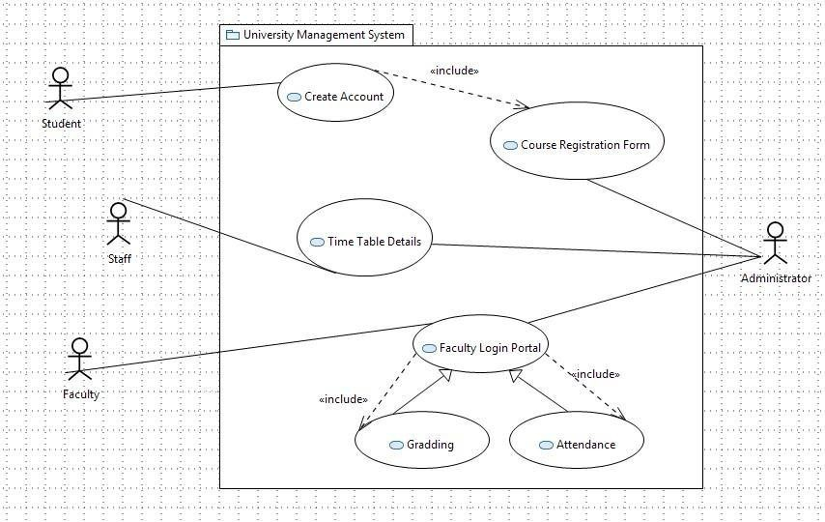

Robustness or Entity Control Boundary Diagram for British University Management :

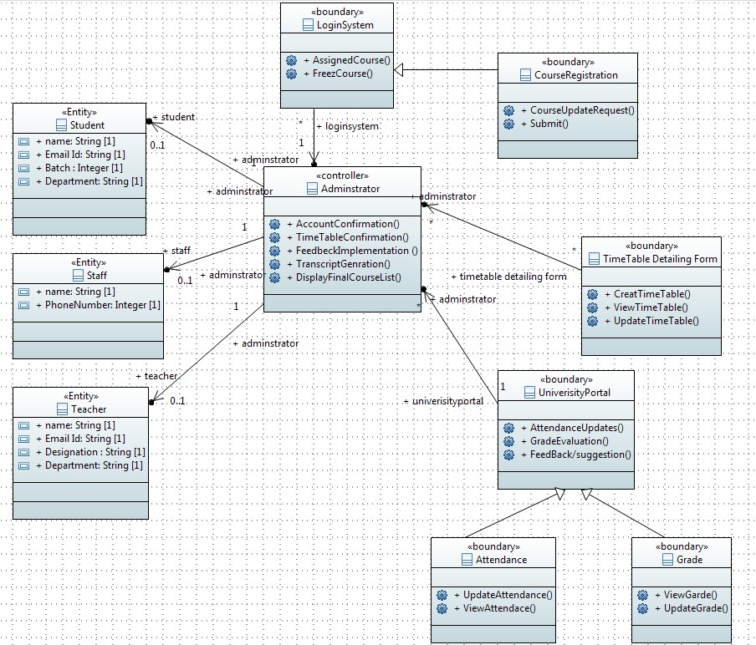

**Robustness Diagram**

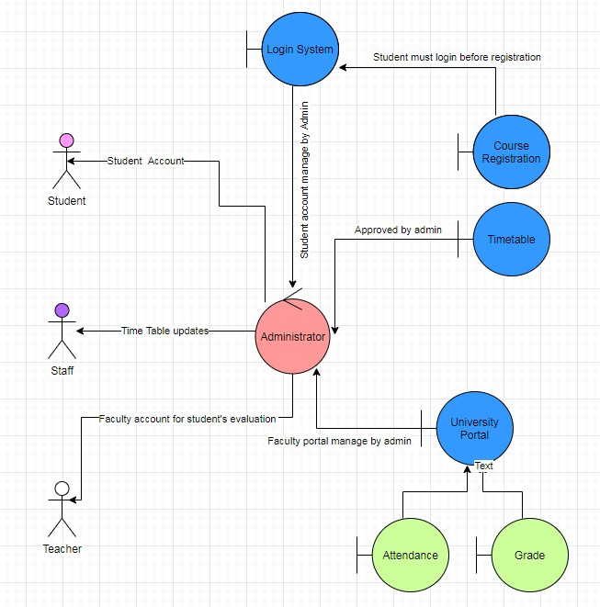

**Elxampe 02: Robustness Diagram from the Use Case**

|  |  |
| --- | --- |
| **User Id** | ***AppUC11*** |
| **Use Case**  **Name** | ***Apply for***  ***scholarship*** |
| *Actor* | Applicant |
| *Description* | Search for international Scholarship |
| *Trigger* | The applicant want to search for foreign fully funded scholarship |
| *Precondition* | Applicant start a web browsing |
| *Postcondition* | Searched result meet with desirable criteria |
| *Normal*  *Flow* | 1. Applicant visit international scholarship websites  2. Applicant click on “apply scholarship” button  3. Listed scholarship page displayed from system  4. Applicant select fully funded scholarship and click apply button  5. System ask for all the academic and personal details  6. After system confirm his/her criteria and will give confirmation email. |

|  |  |
| --- | --- |
| *Alternative*  *flows* | There is no alternative way to apply for international scholarship |
| *Exception* | In step no 06, system will not sent confirmation email to the applicant due to  any missing data. |
| *Include* | None |
| *Issue* | None |

**Robustness Diagram**

1. Visit https://online.visual-paradigm.com/

2. Click on "Start Your Free Trial" within the edition table

3. Enter your email address in the Sign up page and click Sign up to create an online workspace

4. Confirm the confirmation email we sent

5. Done! You can start creating your own drawing with the online drawing tool

